**Name**: Karthikeyan K R

**Date**: 04-01-2024

**Topic**: Running first ETL workload on Azure Databricks

**Type**: Daily Assignment

Creating and Opening my Azure Databricks Service

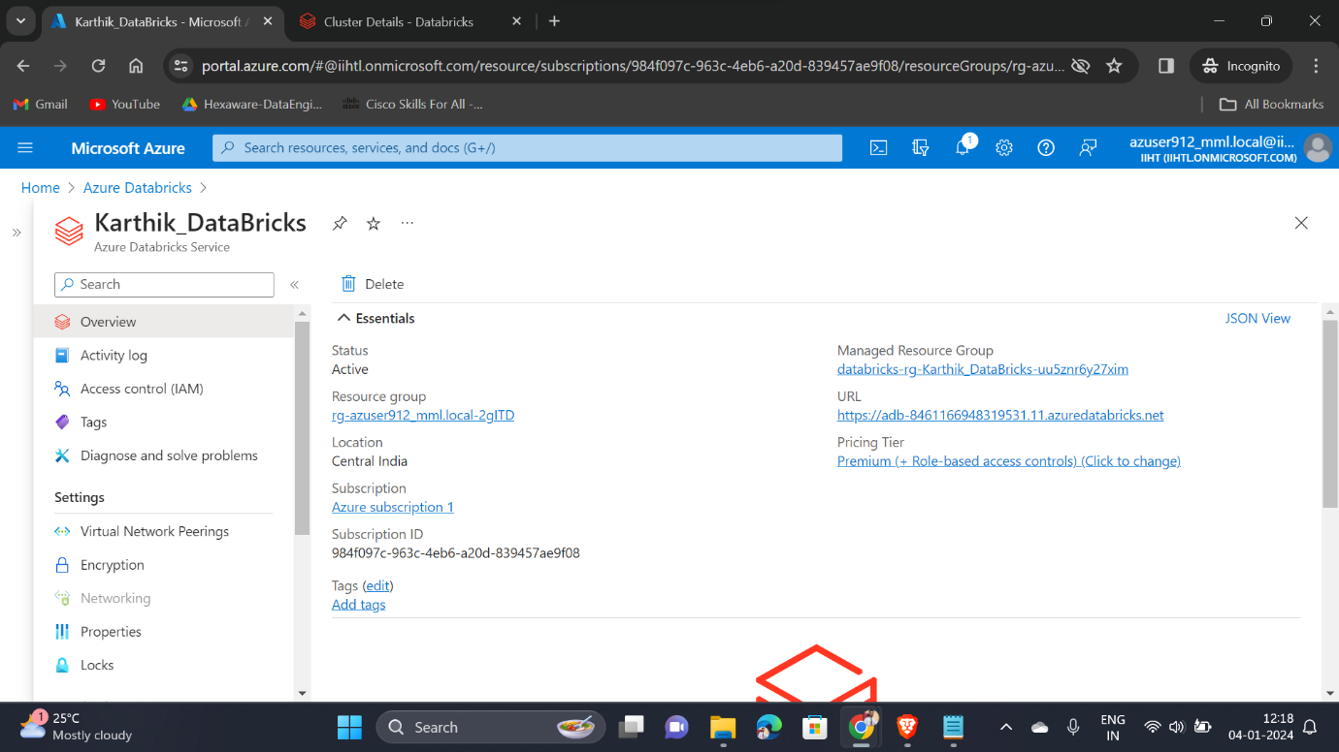

Creating a Cluster on my Azure Databricks

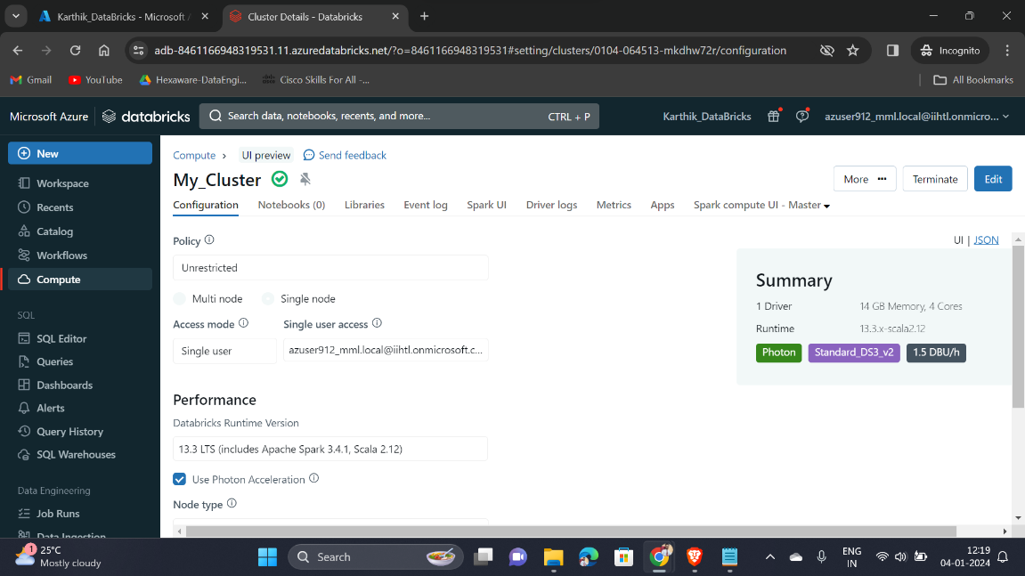

Creating a notebook and adding my created cluster into it

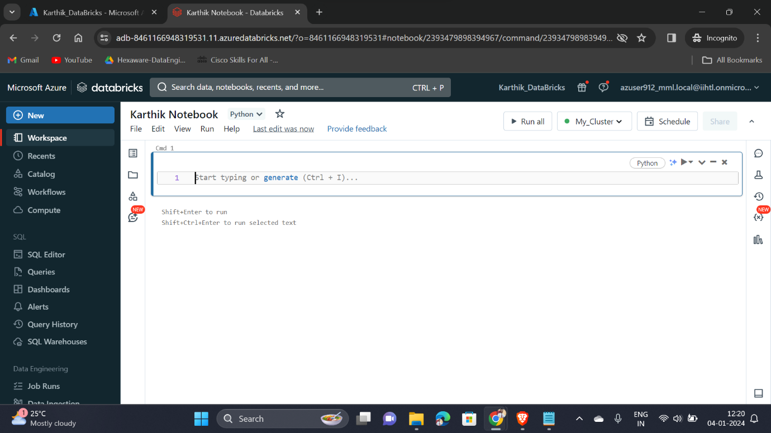

Configuring Auto Loader to ingest data into Data Lake

Executing a python code into the notebook for the configuration process

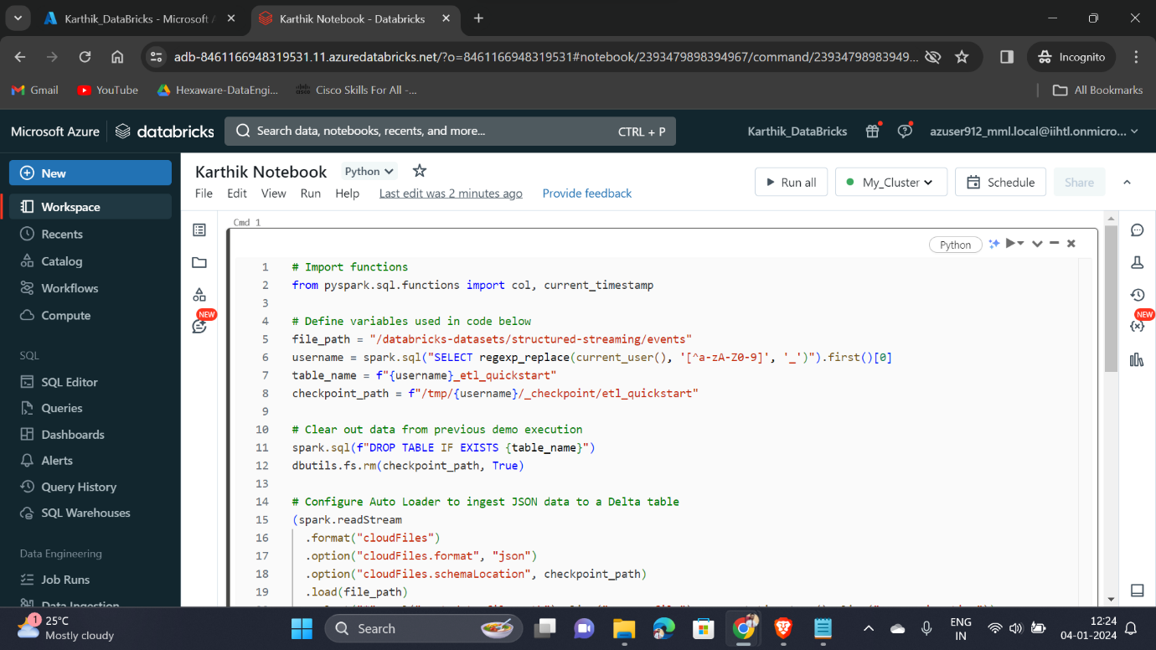

After executing the python code, configuration has been set-up successfully

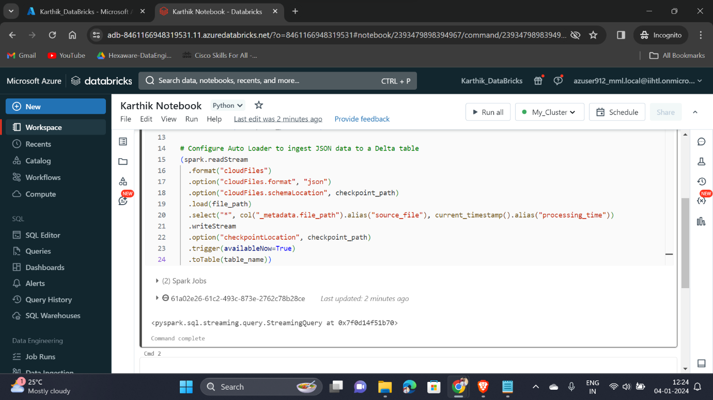

Interacting with the data available in the table

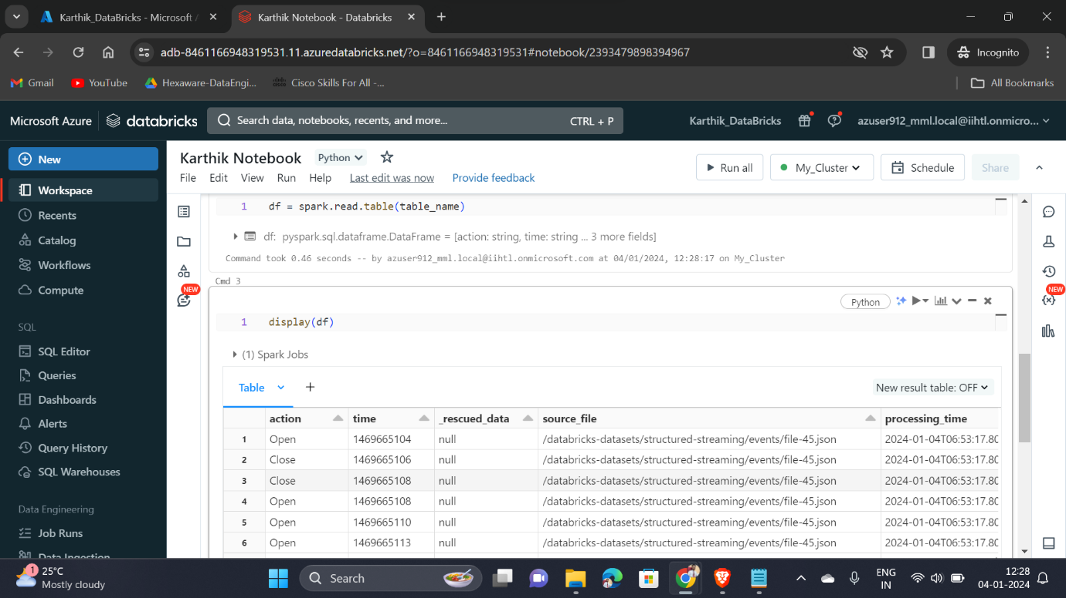

Scheduling a job for execution

